***PAAREES PERFUMES***

***VERSACE***

***FOR UNISEX***

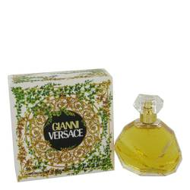

# 

# *Gianni Versace*

## *Description:*

Gianni Versace by Versace Perfume. Created by noted fashion designer Donatella Versace for women who take fashion seriously, Gianni Versace is the perfect accompaniment to your most sophisticated outfits. Pair it with your favorite Versace handbag for a presentation that takes their breath away. This 1981 fragrance is popular among women who crave a hint of spice. The warm, spicy notes are nicely balanced with sweet fruits and the aroma of bergamot. Hints of carnation and tuberose give the fragrance a smooth, lingering finish.